**Technical Documentation – Deploy_BIP_Artifacts Workflow**

1. Workflow – Deploys BI Publisher Artifacts to multiple environments

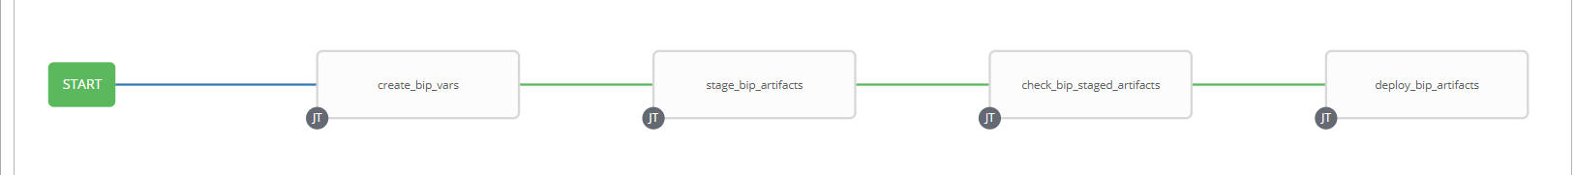

1. Survey – User Supplied Variables

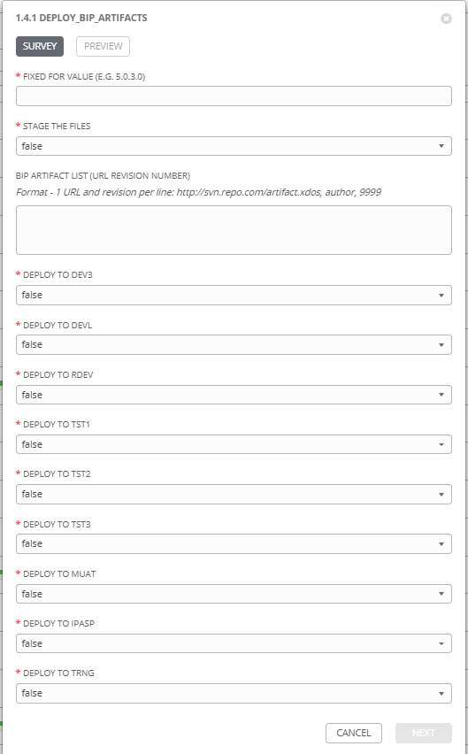

|  |  |  |  |
| --- | --- | --- | --- |
| **Survey Extra Variables** | **Prompt** | **Type** | **Description and Usage** |
| FFV | Fixed For Value | Text | The fixed for value for the deployment – must be for the format ###.###.###.### (i.e. 58.0.12.0). Numbers only with a maximum of 3 digits and there must be 4 sets separated with a ‘.’. Used to create staging and deployments directories. Used by all job templates in the workflow |
| STAGE | Stage the Files | Multiple Choice Single Pick | true or false. Set to ‘true’ to export the artifact(s) from SubVersion. Leave it ‘false’ if the artifact(s) have been previously staged for the entered Fixed For Value. Used by stage_bip_artifacts |
| BIPArtifacts | BIP Artifacts List (URL REVISION NUMBER) | Text Area  16384 Maximum Length | List of BIP Artifacts to Stage – Only needs to be populated if STAGE is set to ‘true’.  Format required is obtained from the Tortoise SVN Repository Browser by right mouse clicking on the artifact and selecting ‘Copy to clipboard’ – ‘Full data’. This is the only format accepted, any changes (i.e. extra or missing spaces and commas) will cause an error |
| DEV3 | Deploy to DEV3 | Multiple Choice Single Pick | true or false. Set to ‘true’ to deploy to this environment. Leave it ‘false’ otherwise |
| DEVL | Deploy to DEVL | Multiple Choice Single Pick | true or false. Set to ‘true’ to deploy to this environment. Leave it ‘false’ otherwise |
| RDEV | Deploy to RDEV | Multiple Choice Single Pick | true or false. Set to ‘true’ to deploy to this environment. Leave it ‘false’ otherwise |
| TST1 | Deploy to TST1 | Multiple Choice Single Pick | true or false. Set to ‘true’ to deploy to this environment. Leave it ‘false’ otherwise |
| TST2 | Deploy to TST2 | Multiple Choice Single Pick | true or false. Set to ‘true’ to deploy to this environment. Leave it ‘false’ otherwise |
| TST3 | Deploy to TST3 | Multiple Choice Single Pick | true or false. Set to ‘true’ to deploy to this environment. Leave it ‘false’ otherwise |
| MUAT | Deploy to MUAT | Multiple Choice Single Pick | true or false. Set to ‘true’ to deploy to this environment. Leave it ‘false’ otherwise |
| IPASP | Deploy to IPASP | Multiple Choice Single Pick | true or false. Set to ‘true’ to deploy to this environment. Leave it ‘false’ otherwise |
| TRNG | Deploy to TRNG | Multiple Choice Single Pick | true or false. Set to ‘true’ to deploy to this environment. Leave it ‘false’ otherwise |

1. Jobs Used by the workflow - http://owl.penc.local:18080/svn/deploy_automation/trunk/Ansible_PlayBooks/BIP

|  |  |  |  |
| --- | --- | --- | --- |
| **Job Template** | **Ansible Playbook** | **Project** | **Description and Usage** |
| create_bip_vars | create_bip_vars.yml | BIP Deployments | Creates Variables/Artifacts for use within the workflows, based on the User supplied survey results.  Artifacts Defined with examples  StageDir: /codemove_common/dp_automation/stage/068.000/068.000.003.000/BIP  DeploymentLogDir: /codemove_common/dp_automation/deployments/068.000/068.000.003.000/BIP  bip_server: ',thanos1bcp,talaus1bcp'  stage_server: diagoras1bcp |
| stage_bip_artifacts | stage_bip_artifacts.yml | BIP Deployments | Stages BIP Artifacts from SubVersion to the {{StageDir}}/artifacts if {{STAGE}} is set to ‘true’ and the {{BIPArtificats}} is populated. BIP Report Artifacts are staged into {{StageDir}}/artifacts/reports. BIP Data Model Artifacts are staged into {{StageDir}}/artifacts/datamodels. |
| check_bip_staged_artifacts | check_bip_staged_files.yml | BIP Deployments | Checks that the staging directory, {{StageDir}}/artifacts exists and that there is at least one report or data models exists in the location. |
| deploy_bip_artifacts | Deploy_bip_artifacs_new.yml | BIP Deployments | 1. Takes a copy of the security.xml file to security.xml.YYYYMMDD_HHMI.pre_deployment. 2. Sets the BIP Admin Password based on the environment. This task is ‘censored’ (i.e. does not display any output) because of the sensitivity of the password 3. Executes the BIPCatalogUtil.sh with baseDir= {{StageDir}}/artifacts. The output of this is ‘censored’ as the {{bi_admin_password}} would be displayed in the output. The STDOUT of the job is stored in the register {{bip_upload_output}} for use in emailed or stored logs. The {{bi_admin_password}} does not get placed in the register. 4. Emails or stores the Logged output along with the predeployment security.xml and the current security.xml files. |

1. HOST Extra Vars – Defined on each host in the Ansible Tower Inventory

|  |  |  |
| --- | --- | --- |
| **Extra Variable** | **Example Values** | **Description and Usage** |
| BIP_Environment | RDEV | This is variable is used within the deploy_bip_artifacts job to set the {{bi_admin_password}} variable for use by the BIPCatalogUtil.sh script (oracle supplied). |
| Bip_lib_dir | /pencmw/oracle/fmw/oracle_home2/bi/clients/bipublisher/lib | Provides the location of the libraries used for the Oracle supplied BIPCatalogUtil.sh script which can be different between BIP environments depending on the current patch level. |
| Bip_util_dir | /pencmw/oracle/fmw/oracle_home2/bi/clients/bipublisher/bin | Provides the location of the binary files used for the Oracle supplied BIPCatalogUtil.sh script which can be different between BIP environments depending on the current patch level. |